Every HMTL page should start with>

<!DOCTYPE html>

Starts with HTML tag, that contains the entire HTML document:

<html lang="en">

Then the head tag, which contains items that describe the main content of the page:

<head>

    <meta charset="UTF-8">

    <meta name="viewport" content="width=device-width, initial-scale=1.0">

    <title>Hello Coursera</title>

</head>

This tag contains metadata about the main content.

The first metatag is the one related to the character set encoding, so the browser knows how to interpret the content of the webpage.

The title is one of the metatags required, without it the HTML would be invalid.

There’s no closing metatag.

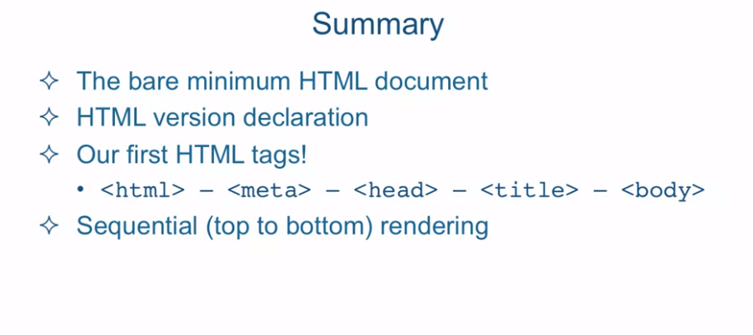

[SOUND] In this lecture we're

going to create a basic HTML document structure by going straight to the editor

and coding one up ourselves and then we'll validate it on

the w3c web validator site. Okay so I'm in Sublime Text and

I have a document open a file open called .-structure.before.HTML. And it's located in the examples,

Lecture04 folder. So we have a blank slate

in front of us and we're going to create our

very first HTML page. So every HTML page should start with

the doc type or document type declaration. The words doc type or

HTML could be lower or upper case. The only thing you have to watch out for is that there shouldn't

be any space between less than exclamation point and

the word doc type. You can have as much space as

you want anywhere else but it just doesn't look that great. So we'll just keep it to one space. In the past, these declaration were pretty

complicated looking, certainly not too many people would be able to type

them up without copy and paste. HTML 5 however changed all that. Now the declaration is

as simple as it can be. All it does is tell the browser that

it should get ready to render HTML. Now I know what some of

you might be thinking. What else would there be if not HTML? There doesn't seem to be any practical

purpose for this declaration. If you're thinking that,

you're absolute right. This declaration is really

largely historical. When HTML standards were

first becoming popular, the web was full of pages that were

not compliant with the standards. To help browsers render those pages

correctly, browsers used the doctype declaration to distinguish between

noncompliant and compliant pages. Noncompliant pages were rendered

in what's called the quirks mode, and the compliant pages were rendered

in what's called the standards mode. Now, that's all historical. But what you need to know today is that if

you leave off the HTML page declaration, that will signal to the browser

that it should treat your pages as one not following HTML standard. I'm not going to go into into what that

would actually mean in practice but needless to say things

would be a bit messed up. Your layout wouldn't work quite right. The styles you apply would

work a bit well quirky. So to make a long story short always use

the simple HTML5 doctype declaration. Next, goes the html tag, and that's basically a tag that

contains the entire html document. After the html tag, goes the head tag. The head tag contains items that

describe the main content of the page. Things like what character coding should

the browser use for the main content. It can contain authors description of

the page, page title, and whatever other external resources are needed to render

the page properly, among other things. The point is it contains some

metadata about the main content. Let's write our first metatag to

specify the character set in coding of our webpage. While not absolutely required, it's always

a good idea to specify the character set that the browser should know how to

interpret the content of the webpage. The most commonly used

character set is UTF 8. Also note that the meta

tag is a stand alone tag. There is no closing meta tag. Next we'll specify the title of the page. The title is one of the tags that

is actually required to be here. Without it, the HTML will be invalid. After the head tag goes the body tag. The body tag is the root of all

content that is visible to the user. It is often referred to as a viewport. We can now write our content. Okay, so let's take a look at

how this looks in the browser. Okay, and here's our page. Let's see the content. Coursera is so cool. I'm learning so much. And you could see that the title,

Coursera is Cool, is also there. Next, let's try to take the code

from our page, and copy and paste it to validate it

inside the W3C validator. And it says we're valid. I'm sure you've noticed by now that what

we're doing is nesting one HTML tag into another. So for example, we could say that

the head tag contains the title tag. One important rule when nesting

html tags is that you have to close the last opened tag before

you close its parent tag. If you don't,

the html you wrote is invalid. So for example here I have a paragraph. And don't worry about what these tags mean

at the moment, but the paragraph tag, p, is closed before the last open tag, span. Span is close after. So if we copy and paste this code and

place it inside our validator and check it,

you will see that it's complaining, and saying that, the end tag p seen,

but there were open elements. In other words, it wants us to close

the span tag, which was opened last, before we close the outer,

p paragraph tag. One more note before we move on. When the browser opens an HTML page. It always renders or interprets the HTML

code sequentially from top to bottom. So the doctype declaration gets

interpreted first, then the HTML tag, then the head tag, and on and on until

it hits the last closing HTML tag. This'll be important to remember as

we progress further into the course. In summary, we went over the bare

minimum HTML document plus weighted sum. We went over the HTML version declaration. And remember, we always have to use it, otherwise the browser will be put into

quirks mode and some things will break. Our first HTML tags. We used html, meta, head, title, body, and actually throw in some

paragraph tags as well. We went over the fact that HTML is

rendered by the browser sequentially, meaning top to bottom. And it renders it top to bottom as well. Next, we're going to talk

about HTML content models.